**Project title :**

**Detecting Pests in Oats Crops Through Deep Learning: A Strategy for Precision Agriculture**

**Introduction :**

Oats are a crucial cereal crop globally, providing essential nutrients for both human consumption and livestock feed. However, pests pose a significant threat to oat production, leading to reduced yields and compromised quality. Detecting pests early and accurately is vital for effective pest management, reducing the need for excessive pesticide use, and promoting sustainable agriculture practices. Traditional pest detection methods are time-consuming and often unreliable. In recent years, deep learning technologies have shown great promise in enhancing pest detection capabilities. By leveraging advanced image processing and artificial intelligence, deep learning models can identify pests in oat crops quickly and accurately, offering an efficient and scalable solution for precision agriculture. This approach can revolutionize pest management strategies and improve crop sustainability.

**Objective of this study :**

The primary objective of this study is to explore the potential of deep learning techniques for detecting pests in oat crops. By developing and training convolutional neural networks (CNNs) and other deep learning models, this research aims to create an automated, high-accuracy pest detection system. The goal is to improve the speed and precision of pest identification, enabling farmers to implement timely interventions. This system would assist in reducing pest-related crop losses, minimizing pesticide use, and enhancing overall crop management. Additionally, the research seeks to evaluate the effectiveness of different deep learning models in terms of performance, scalability, and real-world application in the field, contributing to more efficient and sustainable oat farming practices.

The identified insects and the number of images collected for each were as follows: Armyworm (642), Bird Cherry Oat Aphid (424), Corn Borer (1018), Cutworm (149), Grasshopper (309), Lead Beetle (316), Thrips (470) and Wireworm (532).

**Methodology :**

Data Source:

* Objective: Gather a comprehensive dataset for training and evaluating deep learning models.
* Dataset: "PESTOPIA: Toward the development of an Indian dataset for Pests and Pesticides" (Kaggle).
* Focus: Eight harmful insect species affecting oat crops.
* Pests and Image Counts:
  + Armyworm: 642 images
  + Bird Cherry Oat Aphid: 424 images
  + Corn Borer: 1018 images
  + Cutworm: 149 images
  + Grasshopper: 309 images
  + Lead Beetle: 316 images
  + Thrips: 470 images
  + Wireworm: 532 images

Data Processing:

* Image Resizing: Images resized to a uniform dimension.
* Pixel Normalization: Pixel values normalized for faster training and enhanced performance.
* Data Augmentation: Applied techniques like rotation, flipping, and zooming to artificially enlarge the dataset and improve generalization.

Splitting the Dataset:

* Training Set: Used for training the deep learning model.
* Validation Set: Used for hyperparameter tuning and to prevent overfitting.
* Test Set: Used to evaluate the final performance of the model.

Experimental Setup:

* Platform: Google Colab (cloud-based, free access to GPUs).
* Benefits: Easy to use, open-source, no need for extensive local hardware.
* Purpose: To implement and evaluate deep learning architectures for pest detection efficiently.

**Results and Discussion :**

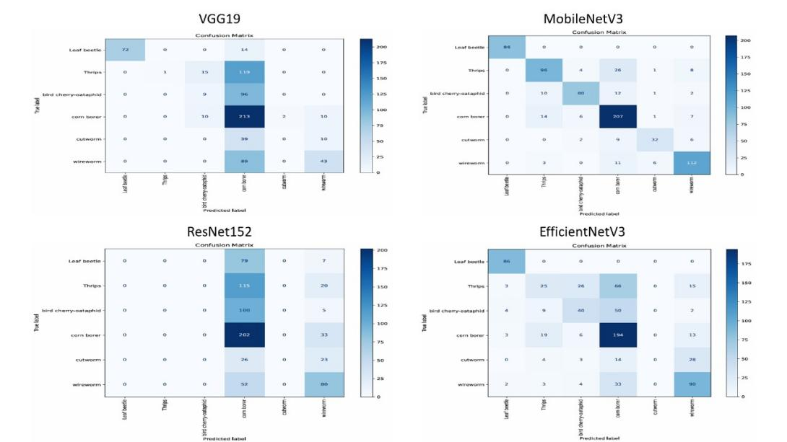

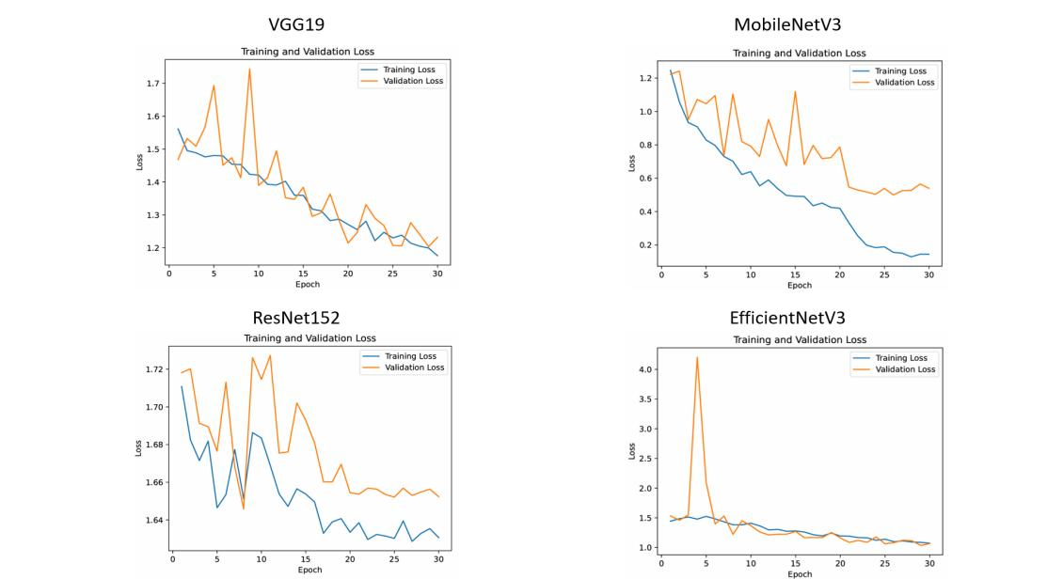



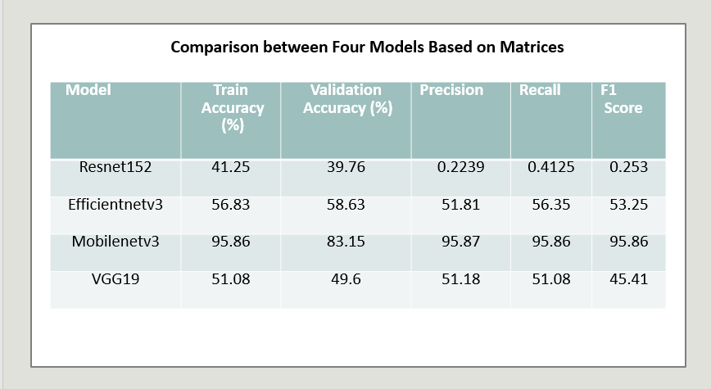

**Significance of this study**

* **Advances pest detection**: This study enhances the accuracy of pest detection in oats using deep learning models.
* **Improves crop protection**: Early pest identification aids in better pest management and reduces crop loss.
* **Supports real-time applications**: Optimized models like MobileNetV3 can be used in resource-constrained environments, such as mobile devices or drones.
* **Enhances agricultural productivity**: Effective pest control contributes to improved yields and food security.
* **Provides model comparison**: Evaluates the effectiveness of multiple deep learning models, guiding future research in pest detection.
* **Promotes sustainable farming**: Helps smallholder farmers by enabling efficient pest management with minimal resources.

**Conclusion :**

A comparative study of deep learning models for oat pest identification found **MobileNetV3** to be the best, excelling in all evaluation criteria with high precision, recall, and F1 score. Its smaller size and efficient performance make it ideal for pest detection. **EfficientNetV2** offers balanced performance and is suitable for applications where computational efficiency is crucial. However, **ResNet152** and **VGG19** showed poor results, with **ResNet152** being especially underperforming. Overall, **MobileNetV3** is the top choice for fast and accurate pest identification, helping improve crop yield by reducing pest-related losses.